Elementos do grupo:

* Diogo Fonseca nº 79858
* Tomás Teodoro nº 80044
* Diogo Silva nº 79828
* Tiago Granja nº 79845

*Screenshots* do programa a funcionar. O programa é capaz de converter de **qualquer** base para **qualquer** base. É possível notar alguma imprecisão quando as bases tendem a ser muito grandes, sendo impossível anular o erro gerado pela imprecisão gerada quando o computador faz aritmética de *floating point* (embora tenha sido minimizada até certo ponto).

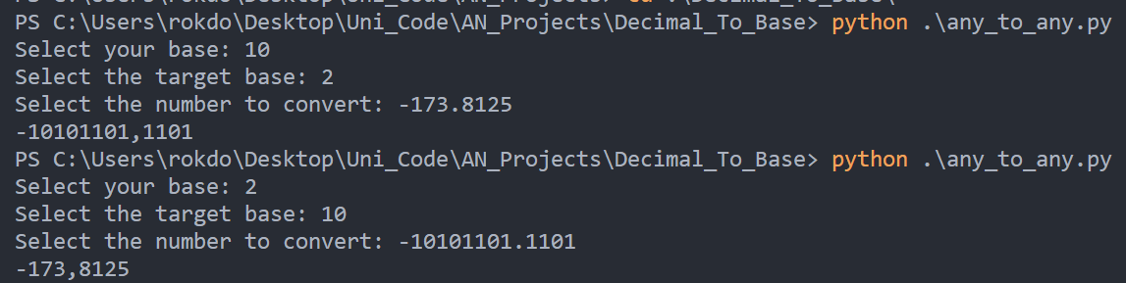

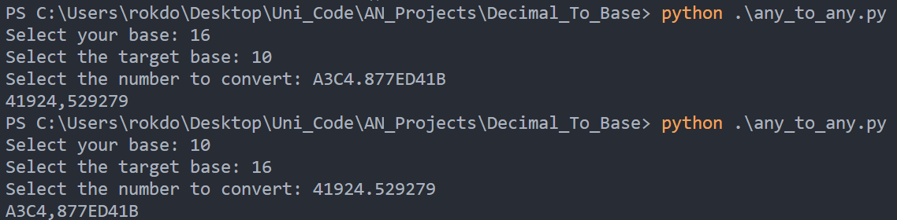

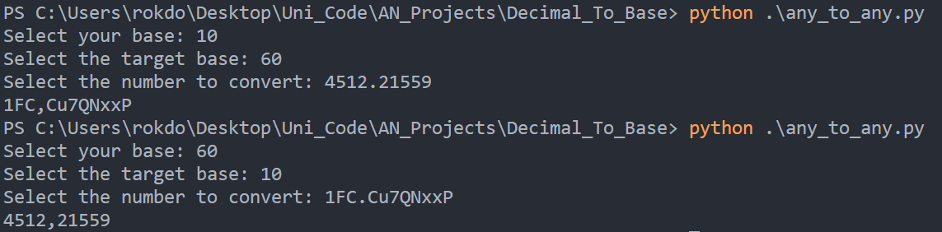

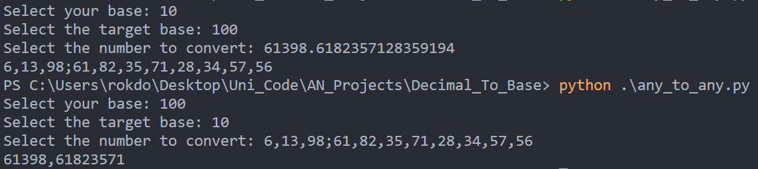

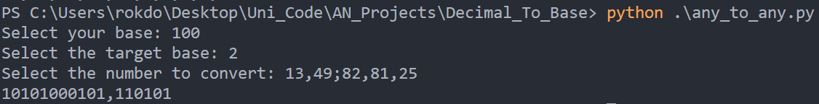

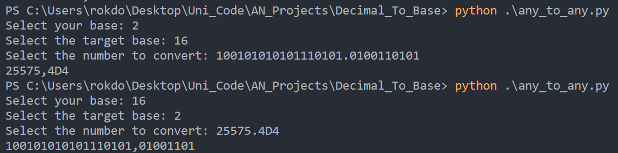

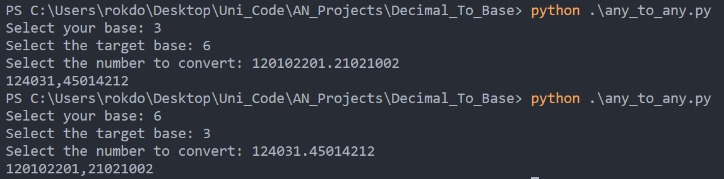

Código:

import math

def convert_base(*x*, *base*):

    y = abs(*x*)

    if *base* <= 10:

        y = decimal_to_less_than_10(y, *base*)

        y = base_round(y, *base*)

    elif *base* <= 61:

        y = decimal_to_less_than_62(y, *base*)

        y = base_round(y, *base*)

    else:

        y = decimal_to_greater_than_61(y, *base*)

    if *x* < 0:

        y = "-" + y

    return y

def decimal_to_less_than_10(*x*, *base*):

    whole = decimal_to_less_than_10_whole(*x*, *base*)

    fractionary = decimal_to_less_than_10_fractionary(*x*, *base*)

    return whole + "," + fractionary

def decimal_to_less_than_10_whole(*x*, *base*):

    y = str(int(*x*))

    if *x* >= *base*:

        y = str(decimal_to_less_than_10_whole(*x* // *base*, *base*)) + str(int(*x*) % *base*)

    return y

def decimal_to_less_than_10_fractionary(*x*, *base*):

    y = ""

    for i in range(9):

*x* -= int(*x*)

*x* = *x* * *base*

        y += str(int(*x*))

    return y

def decimal_to_less_than_62(*x*, *base*):

    whole = decimal_to_less_than_62_whole(*x*, *base*)

    fractionary = decimal_to_less_than_62_fractionary(*x*, *base*)

    return whole + "," + fractionary

def decimal_to_less_than_62_whole(*x*, *base*):

    y = str(int(*x*))

    if *x* >= *base*:

        y = str(decimal_to_less_than_62_whole(*x* // *base*, *base*)) + int_to_alphanumeric(

            int(*x*) % *base*

        )

    else:

        y = int_to_alphanumeric(int(*x*))

    return y

def decimal_to_less_than_62_fractionary(*x*, *base*):

    y = ""

    for i in range(9):

*x* -= int(*x*)

*x* = *x* * *base*

        y += int_to_alphanumeric(int(*x*))

    return y

def decimal_to_greater_than_61(*x*, *base*):

    whole = decimal_to_greater_than_61_whole(*x*, *base*)

    fractionary = decimal_to_greater_than_61_fractionary(*x*, *base*)

    return whole + ";" + fractionary

def decimal_to_greater_than_61_whole(*x*, *base*):

    y = str(int(*x*))

    if *x* >= *base*:

        y = (

            str(decimal_to_greater_than_61_whole(*x* // *base*, *base*))

            + ","

            + str(int(*x*) % *base*)

        )

    return y

def decimal_to_greater_than_61_fractionary(*x*, *base*):

    y = ""

*x* -= int(*x*)

*x* = *x* * *base*

    y += str(int(*x*))

    for i in range(7):

*x* -= int(*x*)

*x* = *x* * *base*

        y += "," + str(int(*x*))

    return y

def int_to_alphanumeric(*x*):

    if *x* >= 10 and *x* <= 35:

        return chr(*x* + 55)

    elif *x* >= 36 and *x* <= 61:

        return chr(*x* + 61)

    return str(*x*)

def alphanumeric_to_int(*char*):

    ascii_value = ord(*char*)

    result = 0

    if ascii_value >= 65 and ascii_value <= 90:

        result = int(ascii_value - 55)

    elif ascii_value >= 97 and ascii_value <= 122:

        result = int(ascii_value - 61)

    else:

        result = int(*char*)

    return result

def base_round(*x*, *base*):

    reverse = *x*[::-1]

    reverse_list = list(reverse)

    reverse_list.pop(0)

    if alphanumeric_to_int(reverse[0]) >= math.ceil(*base* / 2):

        reverse = reversed_base_string_list_add(reverse_list, *base*)

    reverse_list = remove_zeros(reverse_list)

    return "".join(reverse_list)[::-1]

def reversed_base_string_list_add(*reverse_list*, *base*):

    for i in range(len(*reverse_list*)):

        if *reverse_list*[i] == int_to_alphanumeric(*base* - 1):

*reverse_list*[i] = "0"

        else:

*reverse_list*[i] = chr(ord(*reverse_list*[i]) + 1)

            break

    return *reverse_list*

def remove_zeros(*reverse_list*):

    current_char = *reverse_list*[0]

    while current_char == "0":

*reverse_list*.pop(0)

        current_char = *reverse_list*[0]

    if *reverse_list*[0] == ",":

*reverse_list*.pop(0)

    return *reverse_list*

*# ------------------- to decimal -------------------*

def convert_to_decimal(*number_str*, *base*):

    number_str_list = [char for char in *number_str*]

    result = ""

    prepend = ""

    if number_str_list[0] == "-":

        prepend = number_str_list.pop(0)

    if *base* <= 10:

        result = less_than_10_to_decimal(number_str_list, *base*)

    elif *base* <= 61:

        result = less_than_10_to_decimal(number_str_list, *base*)

    else:

        result = greater_than_61_to_decimal(number_str_list, *base*)

    return prepend + str(result)

def less_than_10_to_decimal(*number_str_list*, *base*):

    whole = less_than_61_to_decimal_whole(*number_str_list*, *base*)

    fractionary = less_than_61_to_decimal_fractionary(*number_str_list*, *base*)

    return whole + fractionary

def less_than_61_to_decimal_whole(*number_str_list*, *base*):

    number_list = []

    for character in *number_str_list*:

        if character == ".":

            break

        number_list.append(alphanumeric_to_int(character))

    number_list.reverse()

    k = 0

    result = 0

    for number in number_list:

        result += number * pow(*base*, k)

        k += 1

    return result

def less_than_61_to_decimal_fractionary(*number_str_list*, *base*):

    result = 0.0

    if "." not in *number_str_list*:

        return result

    number_list = []

    for character in *number_str_list*[::-1]:

        if character == ".":

            break

        number_list.append(alphanumeric_to_int(character))

    number_list.reverse()

    k = 1

    for number in number_list:

        result += number / pow(*base*, k)

        k += 1

    return result

def greater_than_61_to_decimal(*number_str_list*, *base*):

    whole = greater_than_61_to_decimal_whole(*number_str_list*, *base*)

    fractionary = greater_than_61_to_decimal_fractionary(*number_str_list*, *base*)

    return whole + fractionary

def greater_than_61_to_decimal_whole(*number_str_list*, *base*):

    number_list = []

    buffer = ""

    for character in *number_str_list*:

        if character == ",":

            number_list.append(int(buffer))

            buffer = ""

        elif character == ";":

            break

        else:

            buffer += character

    if buffer != "":

        number_list.append(int(buffer))

    number_list.reverse()

    k = 0

    result = 0

    for number in number_list:

        result += number * pow(*base*, k)

        k += 1

    return result

def greater_than_61_to_decimal_fractionary(*number_str_list*, *base*):

    result = 0.0

    buffer = ""

    if ";" not in *number_str_list*:

        return result

    number_list = []

    for character in *number_str_list*[::-1]:

        if character == ",":

            number_list.append(int(buffer[::-1]))

            buffer = ""

        elif character == ";":

            break

        else:

            buffer += character

    if buffer != "":

        number_list.append(int(buffer[::-1]))

    number_list.reverse()

    k = 1

    for number in number_list:

        result += number / pow(*base*, k)

        k += 1

    return result

base = int(input("Select your base: "))

target_base = int(input("Select the target base: "))

number = input("Select the number to convert: ")

base_10_number = convert_to_decimal(number, base)

print(convert_base(float(base_10_number), target_base))